TERRANUS: AI-POWERED PERSONALIZED GEOSPATIAL BUSINESS INTELLIGENCE BASED ON LOCAL WISDOM FOR LOCATION DECISION-MAKING
[INSERT SCHOOL / INSTITUTION LOGO OR TERRANUS LOGO]
COMPILED BY
[Author 1 Name]
[Author 2 Name]
[Author 3 Name]
[Author 4 Name]
[SCHOOL / INSTITUTION NAME]
2026
TABLE OF CONTENTS
1. Abstract 3
2. Chapter 1 4
1.1 Research Background 4
1.2 Problem Statement, Objectives and Significance 4
3. Chapter 2 6
2.1 Geospatial Business Intelligence and Site Selection 6
2.2 Local Wisdom and Culturally Aware Systems 6
2.3 AI, Personalization and Explainability 6
4. Chapter 3 8
3.1 Research Design 8
3.2 Materials and Implementation 9
3.3 Recommendation Model 9
3.4 Local Wisdom Knowledge Base Development 10
3.5 Technical and Expert Evaluation Procedure 10
3.6 Planned User Evaluation 10
5. Chapter 4 11
4.1 The TerraNus Product 11
4.2 Local Wisdom Knowledge Base 11
4.3 Data Coverage 11
4.4 Recommendation Quality and Ablation 11
4.5 Functional Testing 12
4.6 Performance 12
4.7 Discussion 12
6. Chapter 5 14
5.1 Conclusion 14
5.2 Implications and Applications 14
5.3 Limitations 14
5.4 Future Work 14
7. References 15
ABSTRACT
Choosing a business location is one of the most consequential decisions for Indonesian micro, small and medium enterprises (MSMEs), yet available site-selection tools are costly, generic and blind to the local cultural knowledge that shapes where people trade, gather and buy. This study aims to design, build and evaluate TerraNus, a web application that combines open geospatial data, a validated local-wisdom knowledge base and an AI recommendation engine to rank candidate locations for a specific business profile and explain each recommendation. A Research and Development approach (4D model) was used, with the Develop stage carried out in five Agile Scrum sprints. TerraNus ranks locations with a personalised multi-criteria score adjusted by expert-validated cultural rules, and a retrieval-grounded language model explains the result in plain language. The knowledge base contains XX rules in X categories, validated by X experts with an agreement of XX. In a case study of city or regency, the full model reached a Spearman correlation of 0.XX with expert rankings, against 0.XX for the geospatial-only baseline. XX of XX automated end-to-end checks passed, and the application loaded in X.XX s on an emulated budget phone. A usability protocol using the System Usability Scale is specified for MSME owners; effects on users have not yet been measured. TerraNus shows that local wisdom can be encoded as measurable, explainable decision criteria and delivered through lightweight web technology.
Keywords: geospatial business intelligence; local wisdom; location decision-making; MSME; personalised recommendation; explainable AI; Agile; web application

CHAPTER 1
Introduction

1.1 Research Background
MSMEs form the backbone of the Indonesian economy and employ most of the workforce [CITE: Ministry of Cooperatives and SMEs / BPS data]. For a small business, the choice of location is hard to reverse: rent, renovation and stock are committed before the first customer arrives, and a poor site can end the business within months. Professional site selection combines geographic information systems (GIS) with multi-criteria decision analysis [1,2], using methods such as the Analytic Hierarchy Process (AHP) and TOPSIS [3,4]. These tools, however, require GIS skills and licences that most MSME owners do not have, so many choose a location by intuition or imitation.
A second gap is cultural. Where people shop, gather and avoid is shaped by local knowledge that rarely appears in map data. A traditional Javanese market follows the five-day pasaran cycle (Legi, Pahing, Pon, Wage, Kliwon), so footfall near it varies by day in a way no population layer shows. Balinese spatial practice, such as Tri Hita Karana and Asta Kosala Kosali, constrains what may be built next to temples and sacred areas. Such knowledge is called local wisdom (kearifan lokal). Culturally situated design research argues that technology works better when community knowledge is built into it rather than added afterwards [6]. Figure 1 maps this situation as a rich picture [13].
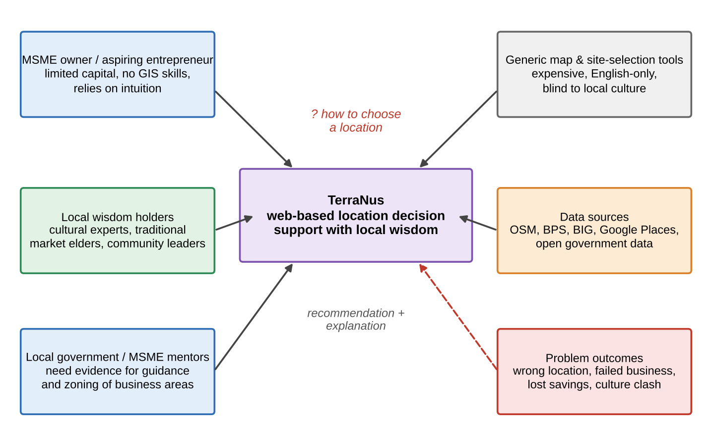
Figure 1. Rich picture of the problem situation and stakeholders.

1.2 Problem Statement, Objectives and Significance
To the authors’ knowledge, widely used location tools treat all places as culturally neutral, are designed for large retailers, and explain their output poorly. This study asks: (1) how can local wisdom be represented as validated knowledge that a web system can process; (2) does adding a local-wisdom layer change the ranking of locations compared with a geospatial-only baseline, and do experts agree with the change; and (3) does the implementation perform reliably on low-cost devices, and how should its usability for MSME owners be tested. The objectives are to design and build TerraNus, evaluate it technically and with experts, and specify a protocol for testing its usability. The significance is practical: a free, understandable tool for entrepreneurs, evidence for local governments and MSME mentors, and a reusable method for turning community knowledge into decision criteria.

CHAPTER 2
Literature Review

2.1 Geospatial Business Intelligence and Site Selection
GIS-based multi-criteria analysis is the standard approach to site selection and has been surveyed extensively [1,2]. Criteria such as population, accessibility, competitors and complementary businesses are normalised and combined with weights, often derived with AHP [3] or ranked with TOPSIS [4]. Open data have lowered the cost of the inputs: OpenStreetMap provides roads and points of interest worldwide [5], and national statistics supply demographic layers. Commercial location-intelligence platforms add foot-traffic analytics but are priced and designed for large organisations and rarely model cultural factors.

2.2 Local Wisdom and Culturally Aware Systems
Ethnocomputing and culturally situated design tools show that community practices can be formalised and embedded in software [6]. For location decisions, local wisdom appears in three forms that can be encoded: temporal patterns (market cycles, festival seasons), spatial norms and constraints (sacred areas, customary boundaries, distance rules), and social preferences (gathering places, trusted trading spots). Encoding them raises the risk of oversimplifying culture and of generalising one region’s practice to another. For this reason knowledge must be collected from community holders, validated by independent experts, and scoped to the region where it applies.

2.3 AI, Personalization and Explainability
Recommender systems adapt results to a user profile and combine content-based, knowledge-based and learned components [7]. Knowledge-based recommendation suits domains with scarce interaction data, as here, where no history of user choices exists. Large language models can generate readable explanations, but without grounding they may state unsupported facts; retrieval-augmented generation reduces this by conditioning the output on retrieved documents [8]. Explanations also matter for trust: people expect contrastive, selective and relevant reasons rather than a full list of internal calculations [9]. Figure 2 and Table 1 summarise the gap.
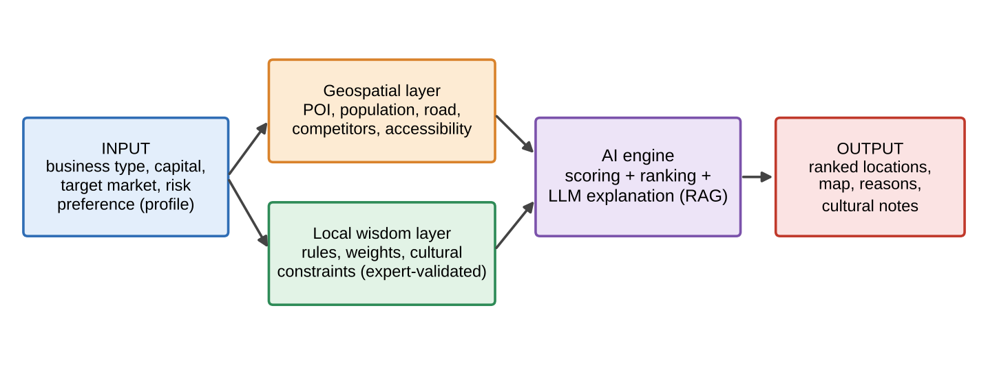
Figure 2. Conceptual framework of the study.
Table 1. Comparison of location-selection approaches (typical characteristics).
Feature | Desktop GIS + MCDA | Commercial location tools | TerraNus
Needs GIS expertise | Yes | Partly | No
Personalised to business profile | Manual | Partly | Yes
Local wisdom criteria | No | No | Built in
Plain-language explanation | No | Varies | Yes
Free and mobile-friendly | Varies | No | Yes

CHAPTER 3
Research Method

3.1 Research Design
This study follows Research and Development using the 4D model (Define, Design, Develop, Disseminate) [12], consistent with the design-science view that a purposeful artefact must be built and evaluated [10,11] (Figure 3). The rich picture from Soft Systems Methodology [13] structured the needs analysis, producing five requirements: R1 local wisdom represented as validated, machine-readable knowledge; R2 geospatial criteria from open data; R3 personalisation by business profile; R4 explainable recommendations including cultural reasons; R5 a lightweight web application with embedded usage logging.
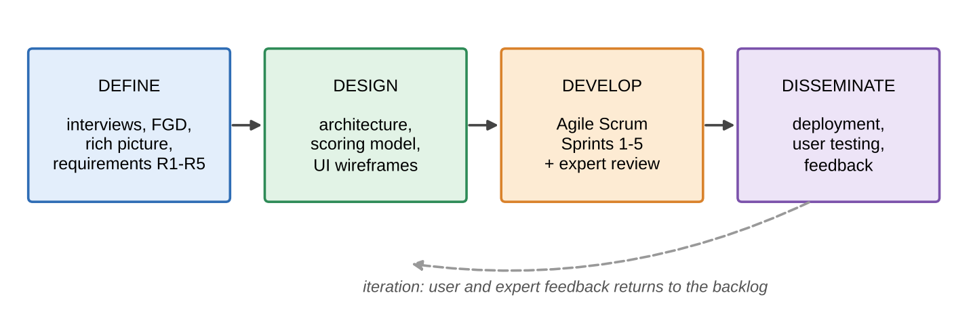
Figure 3. Research flow based on the 4D model.
In the Define stage, X MSME owners and X local-wisdom holders were interviewed and X focus group discussions were held. The Design stage produced the architecture, the scoring model and wireframes. The Develop stage used Agile with Scrum [14,15]: a product backlog of user stories, five sprints of X weeks, and a review and retrospective with users and experts at the end of every sprint (Figure 4). Agile is therefore the development process inside the Develop stage, not the research method itself; the research questions are answered by the evaluations in Section 3.5 and, for usability, by the protocol in Section 3.6. The Disseminate stage covers deployment and the planned user testing.
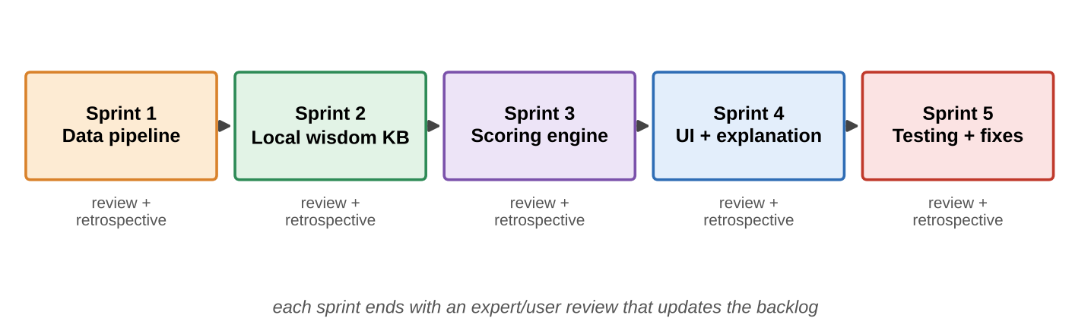
Figure 4. Agile Scrum sprints within the Develop stage.
Table 2. Sprint plan and outputs.
Sprint | Focus | Output | Review with
1 | Data pipeline | Cleaned POI, road and demographic layers | GIS lecturer / mentor
2 | Local wisdom base | Rules, weights and constraints | Cultural experts
3 | Scoring engine | Personalised ranking model | Experts, baseline test
4 | Interface and explanation | Map UI, reasons, cultural notes | MSME owners
5 | Testing and fixes | Release candidate, test report | Users and testers

3.2 Materials and Implementation
TerraNus is a progressive web application (Figure 5). The front end uses HTML, CSS and JavaScript with Leaflet and OpenStreetMap tiles for the map. A Service Worker caches static assets for repeat visits. A server-side API validates requests and runs the scoring engine, spatial data are held in a geospatial store, and the explanation module combines a language model with retrieval over the local-wisdom knowledge base. [Confirm and replace with the actual technology stack, database and AI model used.]
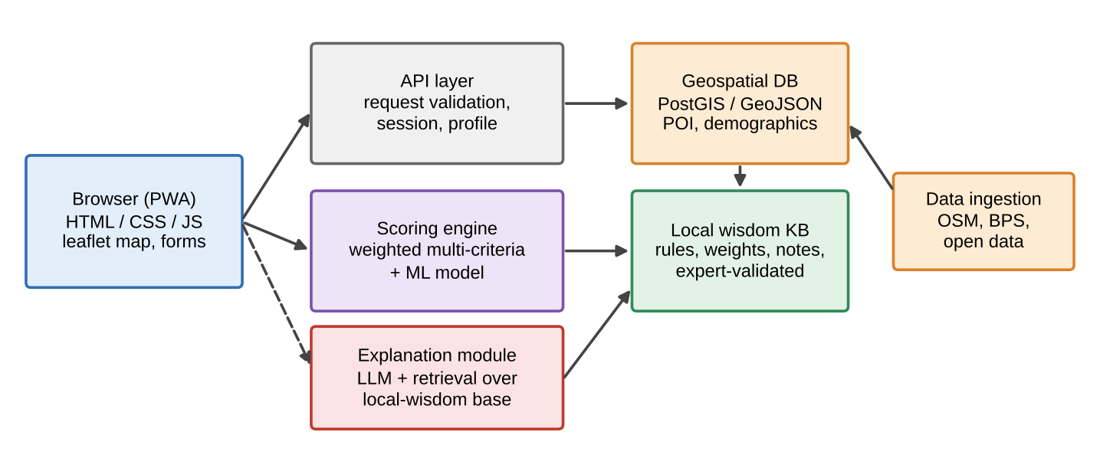
Figure 5. System architecture of TerraNus.
Figure 6 shows the interaction loop. The user enters a business profile (type, capital, target market, risk preference), selects an area, and receives the top-ranked sites with scores, reasons and cultural notes. Each session writes an anonymous log record (timestamp, profile type, area, rank viewed, feedback) used only for the evaluation in Section 3.6.
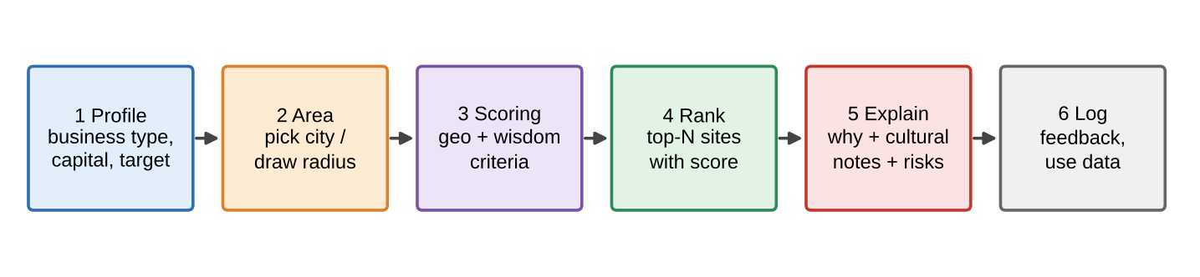
Figure 6. From user profile to explained recommendation.

3.3 Recommendation Model
For a candidate location l and user profile u, the geospatial score combines K criteria x (population density, accessibility, competitor density, complementary POI, rent proxy), each min–max normalised to [0, 1]:
S_geo(l,u) = Σ_k w_k(u) · x_k(l) (1)
The weights w depend on business type and risk preference and were derived with AHP [3] from expert pairwise comparisons, with a consistency ratio below 0.10 required. The local-wisdom score aggregates the cultural rules r that apply at l, each with a validated weight v, and hard constraints c (for example a prohibited distance to a sacred site) act as filters:
S_lw(l) = Σ_j v_j · r_j(l) c(l) ∈ {0, 1} (2)
Score(l,u) = c(l) · [ (1 − λ) · S_geo(l,u) + λ · S_lw(l) ] (3)
The parameter λ sets the influence of local wisdom; it was set to 0.XX after sensitivity analysis. A learned component (optional: describe, e.g. a gradient-boosted model trained on existing business performance data) may refine S_geo when outcome data exist. The explanation module receives only the criteria and rules that actually fired for a location and is instructed to cite them; if retrieval returns nothing, a template explanation is used instead, which limits unsupported statements [8].

3.4 Local Wisdom Knowledge Base Development
Knowledge was collected through interviews, focus groups and literature, then written as structured records: rule text, region of validity, type (temporal, spatial or social), effect (bonus, penalty or hard constraint), weight, source and validator. Weights and validity were reviewed by X experts in two or three rounds using a Delphi-style process [16]. Rules without expert agreement were removed or flagged as unvalidated. Every rule is tagged with its region so that a rule from one culture is never applied elsewhere.

3.5 Technical and Expert Evaluation Procedure
Recommendation quality was tested in case study area. A reference ranking of X candidate sites for X business types was produced independently by X experts, and agreement between raters was measured with Cohen’s kappa [20]. Three variants were compared: (A) a geospatial-only baseline, (B) the full TerraNus model, and (C) an ablation that removes only the local-wisdom layer. Ranking quality was measured with Spearman’s rank correlation and NDCG@3 [17], and the effect of λ was examined by sensitivity analysis. Functional behaviour was tested with XX end-to-end checks in Chromium via Playwright. Start-up time was measured on the live site as the median of three runs on desktop and on an emulated budget phone (1.6 Mbps, 150 ms latency, 4× CPU slowdown), with an empty cache, with the Service Worker cache and offline.

3.6 Planned User Evaluation
Usability will be evaluated with XX MSME owners or prospective entrepreneurs from area, who will complete X location-selection tasks with TerraNus and then answer the System Usability Scale questionnaire [18]. Perceived usefulness and ease of use will be measured with items from the Technology Acceptance Model [19]. Participation will require informed consent, data will be anonymous, and the study will proceed only with approval from [ETHICS COMMITTEE / SUPERVISOR]. Its results are not reported in this paper.

CHAPTER 4
Results and Discussion
[NOTE: all values marked in yellow are placeholders. Replace them with the real measurements from your own tests; do not publish invented numbers.]

4.1 The TerraNus Product
The product is live at [URL] (Figure 7). The interface combines a profile form, an interactive map, a ranked list with scores, and an explanation panel that lists geospatial reasons and cultural notes separately, so users can see which part of a recommendation comes from local wisdom.
[INSERT SCREENSHOTS OF TERRANUS: profile form, map with ranking, explanation panel]
Figure 7. TerraNus screens.

4.2 Local Wisdom Knowledge Base
The knowledge base contains XX validated rules (Table 3). Describe the distribution: for example, X% are temporal, X% spatial and X% social, and which regions they cover. Expert agreement on rule validity was κ = 0.XX, and X rules were removed after the review. This answers RQ1: local wisdom can be represented as typed, weighted, region-scoped records that a system can process and that experts can audit.
Table 3. Composition of the local wisdom knowledge base.
Rule type | Rules | Hard constraints | Expert agreement
Temporal (e.g. market cycles) | XX | XX | 0.XX
Spatial (e.g. sacred areas) | XX | XX | 0.XX
Social (e.g. gathering places) | XX | XX | 0.XX
Total | XX | XX | 0.XX

4.3 Data Coverage
The geospatial layers cover area with XX,XXX POI records, XX km of road network and demographic data at village / district level, from OpenStreetMap, BPS, other. Report completeness checks, for example the share of POI with a category label, and any gaps.

4.4 Recommendation Quality and Ablation
Table 4 compares the three variants against the expert reference ranking. Interpretation: for example, the full model correlated more strongly with experts than the baseline, and the ablation shows how much of the gain comes from the local-wisdom layer. Where the two rankings differ, the reasons were examples. Sensitivity analysis showed that results were stable for λ between 0.XX and 0.XX. This answers RQ2.
Table 4. Ranking quality against the expert reference.
Variant | Spearman ρ | NDCG@3 | Top-1 match
A. Geospatial only (baseline) | 0.XX | 0.XX | XX%
C. Without local wisdom (ablation) | 0.XX | 0.XX | XX%
B. Full TerraNus | 0.XX | 0.XX | XX%

4.5 Functional Testing
XX of XX end-to-end checks passed with no page errors (Table 5).
Table 5. End-to-end functional test results.
Module | Checks | Passed
Profile input and validation | X | X
Area selection and map | X | X
Scoring and ranking | X | X
Explanation and fallback | X | X
Offline and caching | X | X
Total | XX | XX

4.6 Performance
On the budget-phone profile, first contentful paint took X.XX s and full load X.XX s with an empty cache. With the cache, load fell to X.XX s, a reduction of XX%. Offline reload succeeded / failed. Recommendation response time was X.X s for XX candidate sites, and the explanation was generated in X.X s. The application package is X.XX MB. This addresses the performance part of RQ3.

4.7 Discussion
Table 6 summarises how far the requirements were met. Adjust the status to your real evidence. The results support the feasibility of encoding local wisdom as measurable criteria and show the effect of the local-wisdom layer. Usability and user acceptance have not yet been measured. The results also do not show that recommended locations lead to more profitable businesses; that would require outcome data from businesses that followed the recommendations. Expert rankings are also a proxy for ground truth and may carry their own bias. Local wisdom differs between regions, so the knowledge base is valid only for the regions it was built for, and presenting culture as a numeric score risks oversimplification, which is why every rule is traceable to a source and validator.
Table 6. Fulfilment of the design requirements.
Requirement | Evidence | Status
R1 Local wisdom as knowledge | XX validated rules, κ 0.XX | Met / Partial
R2 Open geospatial data | XX,XXX POI, layers | Met / Partial
R3 Personalisation | Weights by profile (AHP, CR < 0.10) | Met / Partial
R4 Explainability | Reasons and cultural notes; template fallback | Met / Partial
R5 Lightweight web | X.XX MB, offline, XX/XX checks | Met / Partial

CHAPTER 5
Conclusion

5.1 Conclusion
This study designed, built and evaluated TerraNus, a web application that ranks business locations with a personalised multi-criteria score adjusted by expert-validated local-wisdom rules, and explains each result. Three contributions stand out. First, local wisdom was represented as typed, weighted and region-scoped rules with documented expert validation, which makes cultural knowledge auditable rather than implicit. Second, an ablation design separates the effect of the local-wisdom layer from the geospatial baseline, so its contribution can be tested instead of assumed. Third, retrieval-grounded explanations with a template fallback give users reasons they can check, delivered by a lightweight web application. Add one sentence stating your main quantitative result.

5.2 Implications and Applications
For entrepreneurs, TerraNus offers a free way to compare locations with reasons they can understand. For local governments and MSME mentors, it gives transparent evidence for guidance and for the planning of business areas. For developers and researchers, it shows a method for converting community knowledge into decision criteria through expert validation, which can be repeated for other regions.

5.3 Limitations
The knowledge base covers only region(s) and a limited set of rules. Expert rankings, not business outcomes, serve as the reference. Open data differ in freshness and completeness between areas. The language model may still produce imperfect wording despite grounding. Performance figures come from emulation / specific devices. Usability and effects on users have not yet been measured; the protocol in Section 3.6 is specified for this purpose.

5.4 Future Work
Planned work starts with the user evaluation in Section 3.6, followed by expanding the knowledge base to more regions with community co-validation, collecting outcome data from businesses that used the recommendations to train and test a learned model, adding live data such as foot traffic and rent, and extending the interface to more regional languages. A longitudinal study could test whether recommended locations improve business survival.

References
[1] J. Malczewski, GIS and Multicriteria Decision Analysis, Wiley, 1999.
[2] J. Malczewski, GIS-based multicriteria decision analysis: a survey of the literature, International Journal of Geographical Information Science, 20 (2006) 703–726.
[3] T. L. Saaty, The Analytic Hierarchy Process, McGraw-Hill, 1980.
[4] C. L. Hwang and K. Yoon, Multiple Attribute Decision Making: Methods and Applications, Springer, 1981.
[5] M. Haklay and P. Weber, OpenStreetMap: user-generated street maps, IEEE Pervasive Computing, 7 (2008) 12–18.
[6] R. Eglash et al., Culturally situated design tools: ethnocomputing from field site to classroom, American Anthropologist, 108 (2006) 347–362.
[7] F. Ricci, L. Rokach and B. Shapira (eds.), Recommender Systems Handbook, 2nd ed., Springer, 2015.
[8] P. Lewis et al., Retrieval-augmented generation for knowledge-intensive NLP tasks, Advances in Neural Information Processing Systems, 33 (2020) 9459–9474.
[9] T. Miller, Explanation in artificial intelligence: insights from the social sciences, Artificial Intelligence, 267 (2019) 1–38.
[10] A. R. Hevner, S. T. March, J. Park and S. Ram, Design science in information systems research, MIS Quarterly, 28 (2004) 75–105.
[11] K. Peffers, T. Tuunanen, M. A. Rothenberger and S. Chatterjee, A design science research methodology for information systems research, Journal of Management Information Systems, 24 (2007) 45–77.
[12] S. Thiagarajan, D. S. Semmel and M. I. Semmel, Instructional Development for Training Teachers of Exceptional Children: A Sourcebook, Indiana University, 1974.
[13] P. Checkland and J. Scholes, Soft Systems Methodology in Action, Wiley, 1990.
[14] K. Beck et al., Manifesto for Agile Software Development, 2001.
[15] K. Schwaber and J. Sutherland, The Scrum Guide, 2020.
[16] H. A. Linstone and M. Turoff (eds.), The Delphi Method: Techniques and Applications, Addison-Wesley, 1975.
[17] K. Järvelin and J. Kekäläinen, Cumulated gain-based evaluation of IR techniques, ACM Transactions on Information Systems, 20 (2002) 422–446.
[18] J. Brooke, SUS: a quick and dirty usability scale, in: Usability Evaluation in Industry, Taylor & Francis, 1996, pp. 189–194.
[19] F. D. Davis, Perceived usefulness, perceived ease of use, and user acceptance of information technology, MIS Quarterly, 13 (1989) 319–340.
[20] J. R. Landis and G. G. Koch, The measurement of observer agreement for categorical data, Biometrics, 33 (1977) 159–174.

